Санкт-Петербургский колледж информационных технологий

МДК 03.01

«Технология разработки программного обеспечения»

**отчёт**

по практической работе №3

Выполнил студент 474 гр.:

Черных Артём

Преподаватель:

Фомин А.В.

Санкт-Петербург 2020

To mark 4

1. Interface programm:

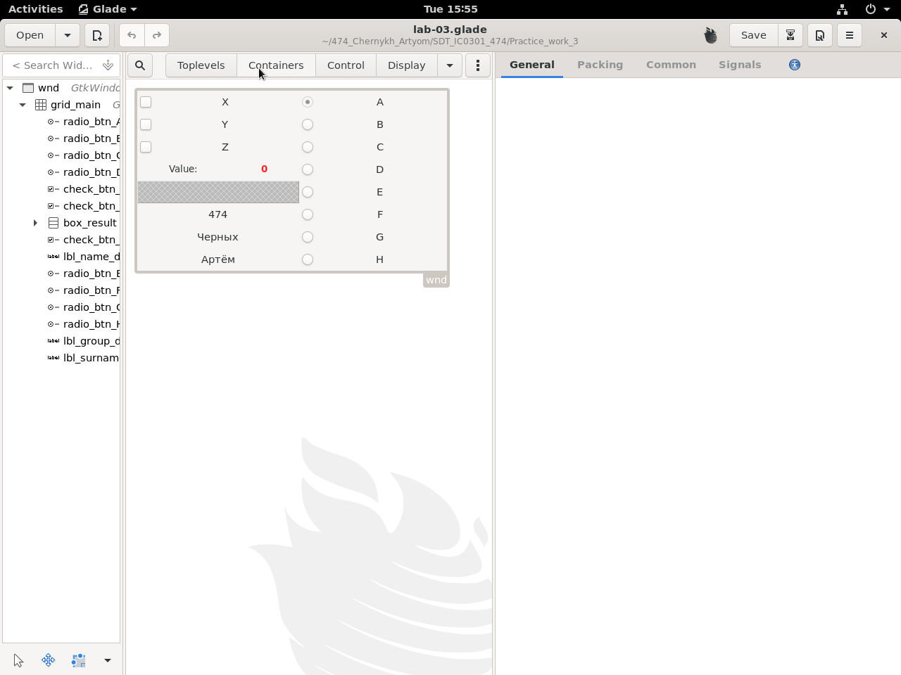

2.Text programm:

Based part(lua):

#!/usr/bin/lua5.3

lgi = require 'lgi'

gtk = lgi.Gtk

gdk = lgi.Gdk

gtk.init()

bld = gtk.Builder()

bld:add_from_file('lab-03.glade')

--[[screen = gdk_screen_get_default();

provider = gtk_css_provider_new();

gtk_css_provider_load_from_resource (provider,

'/SDT_IC0301_474/Practice_work_3/styles_lua.css');

gtk_style_context_add_provider_for_screen (screen,

provider, GTK_STYLE_PROVIDER_PRIORITY_APPLICATION);]]

prov = gtk.CssProvider()

prov:load_from_path('styles_lua.css')

context = gtk.StyleContext()

screen = gdk.Screen.get_default()

context.add_provider_for_screen(screen, prov,

gtk.STYLE_PROVIDER_PRIORITY_APPLICATION)

--@import url('styles_lua.css');

ui = bld.objects

arr_radio_btn = {ui.radio_btn_A, ui.radio_btn_B,

ui.radio_btn_C, ui.radio_btn_D, ui.radio_btn_E,

ui.radio_btn_F, ui.radio_btn_G, ui.radio_btn_H}

function update()

x=0

y=0

z=0

if ui.check_btn_X.active==true then x = 1 end

if ui.check_btn_Y.active==true then y = 1 end

if ui.check_btn_Z.active==true then z = 1 end

value=x+y*2+z*4

arr_radio_btn[value+1].active = true

ui.lbl_res.label=value

end

function ui.check_btn_X:on_clicked()

update()

end

function ui.check_btn_Y:on_clicked()

update()

end

function ui.check_btn_Z:on_clicked()

update()

end

ui.wnd.title = 'lab-03'

ui.wnd.on_destroy = gtk.main_quit

ui.wnd:show_all()

gtk.main()

Aditional part(css):

.value{

color:blue;

}

.group_dev,.surname_dev,.name_dev{

color:green;

background-color:black;

/*linear-gradient(to top, red, violet);*/

}

3. Programm in work:

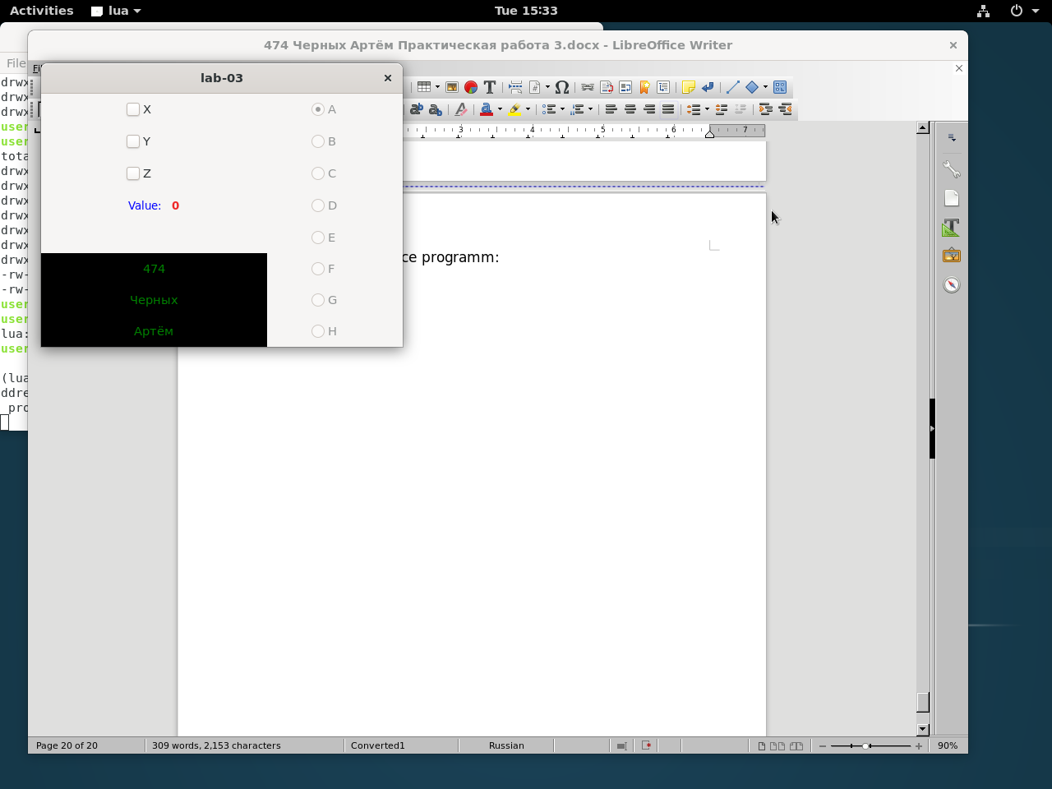

To mark 5

1.Interface programm:

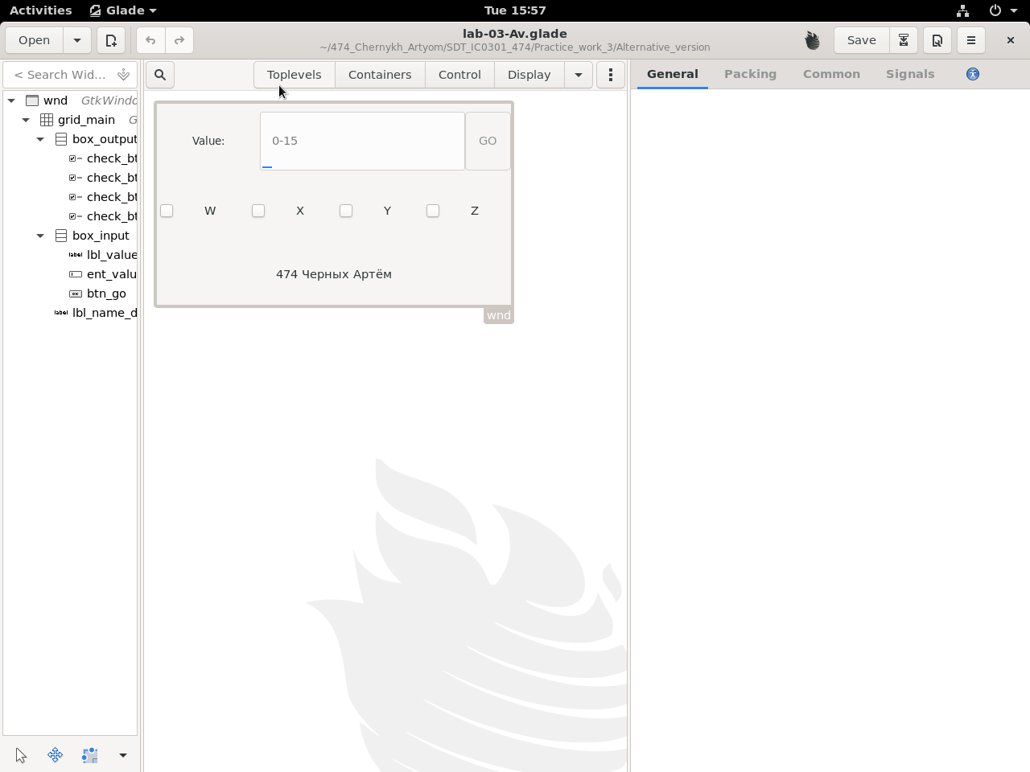

2.Text programm:

Based part(lua):

#!/usr/bin/lua5.3

lgi = require 'lgi'

gtk = lgi.Gtk

gdk = lgi.Gdk

gtk.init()

bld = gtk.Builder()

bld:add_from_file('lab-03-Av.glade')

prov = gtk.CssProvider()

prov:load_from_path('styles_lua_Av.css')

context = gtk.StyleContext()

screen = gdk.Screen.get_default()

context.add_provider_for_screen(screen, prov,

gtk.STYLE_PROVIDER_PRIORITY_APPLICATION)

ui = bld.objects

arr_cb = {ui.check_btn_W, ui.check_btn_X,

ui.check_btn_Y, ui.check_btn_Z}

function ui.ent_value:on_grab_focus()

if ui.ent_value.text == 'error' then

ui.ent_value.text='' end

end

function ui.btn_go:on_clicked()

for i=0, 3, 1 do

arr_cb[i+1].active=false

end

value = tonumber(ui.ent_value.text)

j=8

for i,el in ipairs(arr_cb) do

if (value >= 0 and value <= 15)and value~=nil then

if value/j>=1 then el.active=true

value=value%j

end

j=j/2

else value = nil ui.ent_value.text = 'error'

end

end

end

ui.wnd.title = 'lab-03-Av'

ui.wnd.on_destroy = gtk.main_quit

ui.wnd:show_all()

gtk.main()

Aditional part(css):

.value{

color:blue;

font-size:20px;

}

.box_output{

border: 1px solid red;

}

.name_dev{

color:green;

background-color:black;

/*linear-gradient(to top, red, violet);*/

}

3. Programm in work:

